**DESIGN**

The design is very simple. The arduino has three set of pins namely analog pins, power pins and digital pins. Analog pins are six in total namely A0, A1, A2, A3, A4, A5. Digital pins are fourteen in total. They are: 0 to 13. Power pins are six in total. They are: IOREF, RESET, 3.3v, 5v, GND and GND. Look at the figure for more understanding.

The half breadboard can be used to connection sensors and arduino by using jumper cables. Each row in the main section (i.e center) is denoted by capital alphabet and each column is denoted by number. In half breadboard, there are ten rows divided to two sets (A to E and F to J) and 30 columns (1 to 30) .

Nodemcu module is like the heart of this project. This module connects to WiFi. In this project, two pins are mainly used that is D1 and D2.

**ARDUINO CONNECTION:**

Look at the following table for the arduino connections.

|  |  |  |  |  |
| --- | --- | --- | --- | --- |
| **S No.** | **Component** | **Component- pins** | **Arduino** | **Breadboard** |
| 1 | MQ2 | A0  GND  VCC | A0 | GND  5v |
| 2 | MQ3 | A0  GND  VCC | A1 | GND  5v |
| 4 | MQ135 | A0  GND  VCC | A3 | GND  5v |
| **S No.** | **Component** | **Component- pins** | **Arduino** | **Breadboard** |
| 5 | DHT11 | DATA  GND  VCC | D8 | GND  5v |
| 6 | LDR |  |  | H22 — H24 |

|  |  |  |  |  |
| --- | --- | --- | --- | --- |
| 7 | Jumper |  |  | + — J22 |
| 8 | Jumper |  |  | i28 — minus |
| 9 | Resistor |  |  | H24 — H28 |
| 10 | Jumper |  | A4 | G24 |

Arduino connections

**Nodemcu connections:**

Insert the nodemcu module on the breadboard from B1 to B15 and i1 to i15. Look at the following table for connections:

|  |  |  |  |  |
| --- | --- | --- | --- | --- |
| **S No.** | **Component** | **Component- pins** | **Arduino** | **Breadboard** |
| 1 | Nodemcu | D1  D2 | D1  D0 | A14  A13 |

Nodemcu connections

The D0 and D1 pins in the arduino uno acts as RX and TX pins respectively. Receiving (RX) and Transmitting (TX) pins of Arduino used for Serial communication.

The D1 and D2 pins of nodemcu acts as RX and TX pins respectively and these pins are used for serial communication.

**Thinkspeak:**

thingspeak.com is a website used to store the collected sensor data in the cloud. Steps to create a free thinkspeak account and how to use it.

1. goto https://thingspeak.com/
2. Create an account and goto My Channels.
3. Click on New Channel. The page shows various options such as name, description, Field 1 to 8, etc.
4. Fill the labels as given below
   1. Name as Food Spoilage Detection.
   2. Field 1 as Temperature.
   3. Field 2 as Humidity.
   4. Field 3 as MQ2.
   5. Field 4 as MQ3.
   6. Field 5 as MQ4.
   7. Field 6 as MQ135.
   8. Field 7 as LDR.
5. Save the channel
6. The channel created for this project is in the following link and it is a public channel: https://thingspeak.com/channels/1400396

**IFTTT:**

[ifttt.com](http://ifttt.com) is a webiste used to create applets. This website is useful for sending mails to the user. Applet connects the nodemcu module and email. Steps to create a free ifttt account and how to use it.

1. goto [ifttt.com/](http://ifttt.com) and create a free account.
2. Click on create on the navigator bar.
3. Press add button on if This label.
   * 1. Search for webhooks service
     2. Click on receive a web request
     3. Type event name as food spoiled.
4. Press add button on Then That label
   * 1. Search for email service
     2. Click on send me an email
     3. Create on create action
5. Press Continue
6. Click on finish

For this project, Two applets are created.

1. Sends an email if the air quality around the food is not good.
2. Sends an email if the food is spoiled.

**FreeBoard:**

[freeboard.io](http://freeboard.io) is a website used for visualization. It’s open source. Create a free account.

**Block diagram:**

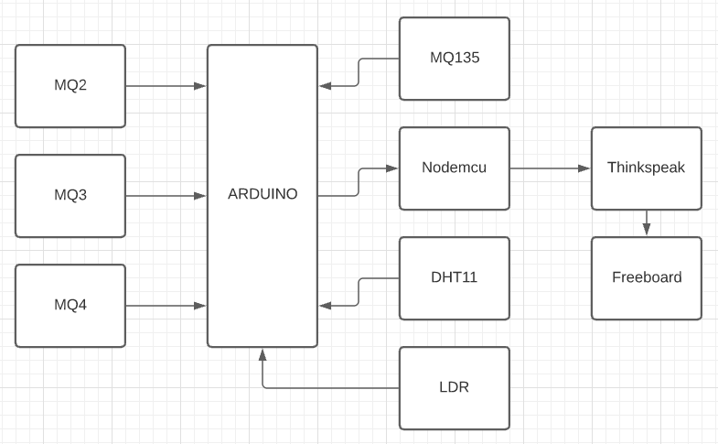

**Circuit diagram:**

